*Du lundi 19 mars au vendredi 23 mars 2018*





*Pendant ton séjour à Londres tu vas avoir plusieurs missions à mener à bien Tu vas devoir :* O*bserver ton nouvel environnement et prendre des notes. Prendre aussi des photos, faire des croquis de voyage. Repérer des lieux, trouver des infos et des objets divers.*

*Ce petit livret t’aidera à conserver une trace de tes recherches et te donnera du vocabulaire et des informations précieuses. Prends en soin.*

# My Host Family

|  |  |
| --- | --- |
| Name | Mr/Mrs / Miss |
| Number of persons |  |
| House | http://www.jetoboj.cz/wp-content/detached-house1.jpghttps://encrypted-tbn1.gstatic.com/images?q=tbn:ANd9GcT4nTaApJiJ1w6WbRwlOG7kmXMedGf1aigBdRbRtF-gSOih2TWNvAhttps://encrypted-tbn2.gstatic.com/images?q=tbn:ANd9GcQXgODWARRUTLvUCAqrZ8Vra_rWx-0hvUrEVKPs85pBYeRNlSCDPg https://encrypted-tbn1.gstatic.com/images?q=tbn:ANd9GcRsW2nIxFzmlSSgn3qm40yLBCkeksuq9EwGX_zGzO4QlkuAakYe  ⃝ A block of flats ⃝ a terraced house ⃝ A semi-detached house ⃝ detached house |
| Room’s number |  |
| Difference with French houses |  |

* **Your English morning :**

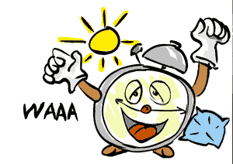

* Awakeningtime: ……………………………………………………………………………… ;

Breakfast time : ………………………………………………………..

* Food

|  |  |  |  |  |  |  |  |
| --- | --- | --- | --- | --- | --- | --- | --- |
| cereals | milk | Toast | Coffee | jam | Orange juice | tea | A piece of fruit |

* Transport to meet the group

|  |  |  |
| --- | --- | --- |
| I walked | My family drove me | I cycled |

* **Your English evenings**

Did you watch TV ? ………………………………………………………………………………………..…………

What did you watch ? …………………………………………………………………………..…….

Otherthings …………………………………………………………………………………………………………

……………………………………………………………………………………………………………..

Bedtime : …………………………………………………………………………………..

English Food

|  |  |  |
| --- | --- | --- |
|  | Lunches |  |
| Monday |  | I didn’t like ……………… I liked ………………… |
| Tuesday |  |  |
| Wednesday |  |  |
| Thursday |  |  |

|  |  |  |
| --- | --- | --- |
|  | DINNERS |  |
| Monday |  | I didn’t like ……………… I liked ………………… |
| Tuesday |  |  |
| Wednesday |  |  |
| Thursday |  |  |

Day 1 : Canterbury

* + - In the morning during the trip

|  |  |
| --- | --- |
| I liked |  |
| I didn’t like |  |

* + - In the afternoon inCanterbury

|  |  |
| --- | --- |
| I liked |  |
| I didn’t like |  |

|  |  |
| --- | --- |
| What we did : |  |

Day 2 London

* + - In the morning a walk in London

|  |  |  |  |  |  |  |  |  |  |  |  |  |  |  |  |  |  |  |  |  |  |  |  |  |  |  |  |  |  |  |  |  |  |  |  |  |  |  |  |
| --- | --- | --- | --- | --- | --- | --- | --- | --- | --- | --- | --- | --- | --- | --- | --- | --- | --- | --- | --- | --- | --- | --- | --- | --- | --- | --- | --- | --- | --- | --- | --- | --- | --- | --- | --- | --- | --- | --- | --- |
| |  |  |  |  | | --- | --- | --- | --- | | ⃝ the Tower of London | ⃝ Tower Bridge | ⃝Trafalgar Square | ⃝ Buckingham Palace | | aa47 | aa45 | aa41 | aa43 | | ⃝ Picadilly Circus | ⃝ Westminstr Abbay | ⃝ Big Ben and the Houses of Parliament | ⃝ Saint Paul’s cathedral | | aa46 | wembley.png | http://www.tourist-information-uk.com/uploads/images/attraction_images/164/xlarge/00011_1.jpg | gherkin.png | | ⃝ the London Eye | ⃝ Wembley Stadium | ⃝ Horse Guard Parade | ⃝ the Gerkin | | Globe | http://www.idealwine.net/wp-content/uploads/2014/02/downing-street.jpg | http://www.officiel-galeries-musees.com/uploads/lieux/e5e100b1bee216bdd54b08309424a1eff0f7c9ac.jpg | https://encrypted-tbn1.gstatic.com/images?q=tbn:ANd9GcSyQy7M57EeEn1ScMJudnw7BpBdMeWsODx0n_gr_bI_AyZdKDY4mQ | | ⃝ the Globe Theatre | ⃝ 10 Downing Street | ⃝ Tate modern | ⃝ the British Museum | | https://encrypted-tbn2.gstatic.com/images?q=tbn:ANd9GcTDaddxo8THw1JnCq8HyajlVk7H4I53zK7EsVOH3lmXQEnRGwyt | https://encrypted-tbn3.gstatic.com/images?q=tbn:ANd9GcT7VJZk9MRzPRRcES8jGf6ZyVj45dKlKQZ7XfpSqscOrhlbtrNeEQ | http://www.travelstay.com/francais/images/385649/5/Hyde_Park.jpg | http://laurapurcell.com/wp-content/uploads/2013/10/kveen0175s.jpg | | ⃝ St James’ Park | ⃝ the Town Hall | ⃝ Hyde Park | ⃝ St James’ Palace |   Seen any other landmarks?  ................................................................................................................................................................................................................................................................................................................ |  |  |  |

|  |  |
| --- | --- |
| I liked |  |
| I didn’tlike |  |

# 

# In the afternoon Natural Museum



Questions to answer:

* Give the name of two dinosaurs: .............................................................................

....................................................................................................................................

What is the biggest dinosaur?

.................................................................................................................................

* What is the French for a 'whale'? In what section can you see it? ..................................................................................................................................................................................................................................................................................
* Is a snake a fish a mammal a reptile

Give the name of a colour ful snake: ...........................................................................

* What is the name of the biggest tree in the world? .....................................................
* Give the name of a small bird? ..................................................................................
* Give the name of a big bird? ...................................................................................
* When were the first men born? ................................................................................
* Is a butterfly bigger than an ant? YES NO
* What is the French for "crawlies"? .........................................................

Give two examples: ......................................................... and .........................................................

|  |  |
| --- | --- |
| I liked |  |
| I didn’tlike |  |

# Day 3 London

* In the morning a panoramic visit in London

|  |  |
| --- | --- |
| I liked |  |
| I didn’t like |  |

|  |  |
| --- | --- |
| What you saw  and what you remember |  |

# Full English breakfast in Garfunkel restaurant

|  |  |
| --- | --- |
| I liked |  |
| I didn’t like |  |

# Dreamgirls, Savoy Theatre

|  |  |
| --- | --- |
| I liked |  |
| I didn’t like |  |

Who are the heroines? .............................................................................................

When does the story take place? .............................................................................

Where does the story take place? ..........................................................................

Résumez l'histoire en français : ......................................................................................... ........

......................................................................................................................................................................................................................................................................................................................................................................................................................................................................................................................................................................................................................................................

......................................................................................................................................................................................................................................................................................................................................................................................................................................................................................................................................................................................................................................................

Ecrivez les paroles dont vous vous souvenez: ......................................................................................................................................................................................................................................................................................................................................................................................................................................................................................................................................................................................................................................................................................................................................................................................................................

Dessine ce qui t'inspire :

# Day 4 London. At the Tate Modern.

* Find the painting of a woman painter of the 20th century:

Title: ................................................................................................................................

Artist: ............................................................................................

Date: ........................................................................................

* Find a strange painting for you:

Title: ................................................................................................................................

Artist: ............................................................................................

Date: ........................................................................................

* Find two creations by Modigliani:

Title: ................................................................................................Date: .............................

Title ............................................................................................Date: .................................

Find a surprising work of art for you:

Title: ................................................................................................................................

Artist: ............................................................................................

Date: ........................................................................................

Find a work of art of the 21st century:

Title: ................................................................................................................................

Artist: ............................................................................................

Date: ........................................................................................

If you can, draw, imitate or create your own work of art:

# Mini-croisière sur la Tamise

|  |  |
| --- | --- |
| I liked |  |
| I didn’tlike |  |

# Dîner fish and chips at the Albert Restaurant

|  |  |
| --- | --- |
| I liked |  |
| I didn’t like |  |

# Mes photos et les impressions de mon séjour !!

# English survival kit

Formules de politessse:

S’il vous plaît = **Please** Merci = **Thank you (very much)**

S’excuser = **Excuse me / I’m sorry** Pour accepter= **Yes, please** Pour refuser = **No, thank you**

Pour saluer: **Good morning / Good afternoon / Good evening / Good night / Goodbye**

Si vous ne comprenez pas:

Pouvez-vous répéter s’il vous plaît? = **Can you repeat please?**

Pouvez-vous parler plus lentement s’il vous plaît?=**Can you speak more slowly please?**

Je ne comprends pas = **I don't understand**

Pouvez-vous l’écrire s’il vous plaît?= **Can you write it down for me please?**

Première rencontre:

Comment allez-vous?= **How are you? / How do you do** (très poli )

Je vais bien, merci. / Je suis fatigué (e) = **I’m fine thank you. / I’m tired.**

Ravi (e) de vous rencontrer = **Pleased to meet you.**

Comment t’appelles-tu? = **What is your name?**

Je m’appelle....= **My name is ........... Iam ...................**

Où sont vos bagages?= **Where is your luggage?**

Voici mes bagages = **This is my luggage**

Dans la voiture en allant chez votre famille d’accueil:

Votre ceinture de sécurité = **Your seat belt!**

D’où êtes-vous? = **Where are you from?**

Je viens/ nous venons de France / Lyon= **I am / We are from France / Lyon**

Comment s’est passé votre voyage?= **How was your trip?**

J’ai fait bon voyage, merci. = **I had a nice trip, thank you.**

Depuis combien de temps apprenez-vous l’anglais?= **How long have you studied English?**

J ’apprends l’anglais depuis 3 /4 ans = **I have studied English for three / four years**

Est-ce votre premier séjour en Angleterre?=**Is this your first stay in England?**

Santé:

Je ne me sens pas très bien = **I don't feel very well**

J’ai mal à la tête/ au ventre = **I have a headache / I have a badstomach**

J’ai mal aux dents/ à la gorge = **I have a toothache / I have a sore throat**

Je suis allergique à......= **I amallergic to ........**

Puis-je appeler mon professeur?= **May I phone my teacher?**

At home, the first evening :

Suivez-moi, voici votre chambre = **Follow me. This is your room.**

Voici la salle de bains, les toilettes = **This is the bathroom , the toilet.**

Puis-je prendre une douche?= **May I have a shower?**

Vous pouvez prendre une douche = **You can have a shower**

Avez-vousfaim? / J’ai faim = **Are you hungry? / I am hungry.**

Avez-vous soif? / J’ai soif = **Are you thirsty? / I am thirsty.**

Pouvez-vous me réveiller à 7 heures demain matin?= **Could you wake me up at 7 tomorrow morning?**

Y-a-t-il certaines choses que vous n’aimez pas manger?= **Is there any food you don't like?**

J’aime..../ Je n’aime pas.....= **I like ....... / I don’t like......**

Famille : mari/femme/fils/fille/père/mère= **family: husband/ wife/ son/ daughter/ father/ mother**

Avez-vous des frères et des sœurs? =**Have you got any brothers and sisters?**

Je vous ai apporté un petit cadeau = **I've brought you a little present.**

Puis-je utiliser la salle de bains/les toilettes?= **May I use the bathroom/ the toilet?**

Où puis-je me laver les mains?= **Where can I wash my hands?**

Pourrais-je avoir une serviette, s’il vous plaît = **Could I have a towel, please?**

Pourrais-je avoir une autre couverture, s’il vous plaît?= **Could I have another blanket, please?**

Où est la poubelle? = **Where is the dustbin?**

Comment allume-t-on/éteint-on la lumière?= **How do you switch on / off the light?**

Puis-je emprunter un sèche-cheveux?= **Can I borrow a hairdryer?**

Puis-je regarder la télévision? = **May I watch television?**

Je suis fatigué(e), puis-je aller me coucher?= **I'm tired, may I go to bed?**

In the morning, you may hear:

Bonjour, comment allez-vous aujourd’hui?= **Good morning, how are you today?**

Avez-vous bien dormi?=**Did you sleep well? ( Yes, thank you )**

Que voudriez-vous pour le petit déjeuner?= **What would you like for breakfast?**Thé/café/chocolat/céréales/tartines/confiture? = **Tea/coffee/chocolate/cereals/toasts/jam?**

Voici votre repas de midi = **This is your packed lunch.**

Je vous amène au point de rendez-vous = **I'm going to take you to the meeting point**

A plus tard/ Passez une bonne journée = **See you later / Have a nice day**

Meals at home:

petit déjeuner/déjeuner/dîner= **breakfast/ lunch/ tea or dinner**

A quelle heure est le petit déjeuner? = **What time is breakfast ?**

Voulez-vous un peu de...? = **Would you like some .........?**

Puis-je en avoir un peu plus s’il vous plaît?= **May I have some more please?**

J’aime...../ je n’aime pas .../ je préfère... = **I like.... I don’t like.....I prefer.....**

Je suis végétarien = **I'm a vegetarian**

Je ne peux manger que de la nourriture kasher/ Halal = **I can only eat Kosher /Halal food.**

Je suis désolé(e) mais je n’ai pas le droit de manger... = **I'm very sorry but I'm not allowed to eat ...**

Puis-je vous aider à faire la vaisselle?= **Can I help you with the washing up?**

C’était bon/ délicieux/ je me suis régalé(e) = **That was nice / delicious/ I really enjoyed that.**

Je voudrais un verre d’eau/de lait/jus de fruit = **I would like a glass of water/milk/fruit juice**

**Lovely** = bon, joli, agréable, sympa....

In town

Comment va-t-on a... ? = **Could you tell me the way to... ?**

Pouvez-vous me dire ou se trouve... ?=**Could you tell me where the … is?**

Où sommes-nous ? = **Where are we ?**Tout droit = **go straight on.**

Prends a gauche / a droite = **Turn left / right.** Traverser = **Cross / Go across** La rue = **The street** Un feu de circulation = **A traffic light**

Un passage pieton = **A pedestrian crossing** Nous cherchons... = **We're looking for.**

Shopping

Un magasin = **A shop** Un supermarché = **A supermarket** Le centre commercial = **The shopping centre** Acheter / vendre = **buy / sell** Combien c’est, s’il vous plait ?**How much is it please?** Le prix = **The price** Je peux essayer?= **Can I try it on?**  La cabine d’essayage = **The fitting room**

Trop petit (≠grand) = **Toosmall/Too large** La taille = **The size**

Je voudrais... = **I would like...**

Un timbre pour la France = **A stamp for France** Une carte postale = A postcard

La boite aux lettres = **The letter box** La poste **= The post office**

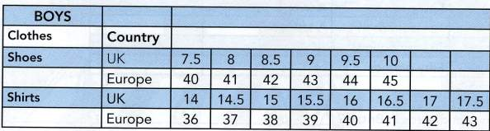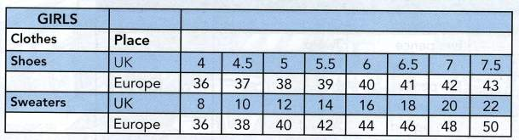

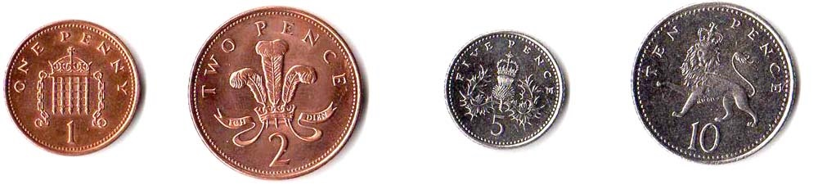Coins:

**a penny two pence five pence ten pence**

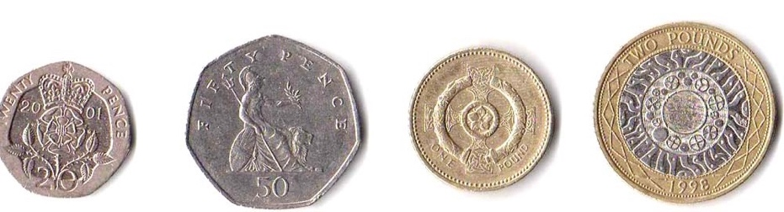

**twenty pence fifty pence one pound two pounds**

Notes :

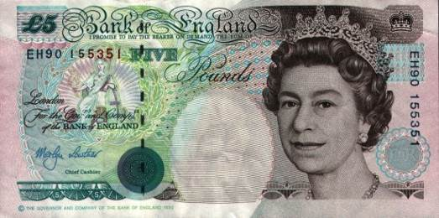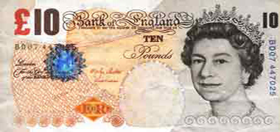

**five pounds ten pounds**

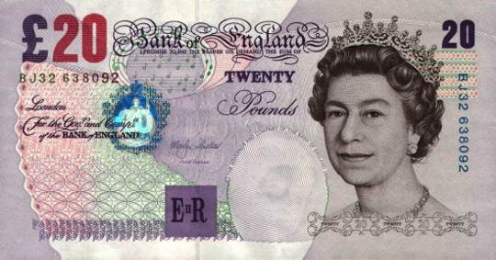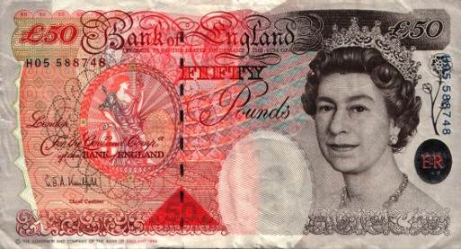

**twenty pounds fifty pound**

Useful vocabulary

|  |  |  |  |  |
| --- | --- | --- | --- | --- |
| **FRENCH to ENGLISH** | | | | |
| **FOOD** | |  | **HEALTH / CLOTHES** | |
| à point (cuisson) | **well-done** |  | 'gant' pour la toilette | **a flannel** |
| assiette | **a plate / a dish** |  | bandage | **a bandage** |
| bâtonnets de poisson | **fishfingers** |  | brosse | **abrush** |
| bleu (cuisson) | **rare** |  | cachet | **atablet** |
| bonbons | **sweets** |  | casquette | **a cap** |
| champignon | **mushroom** |  | ceinture de sécurité | **aseatbelt** |
| chips | **crisps** |  | chaussettes | **a pair of socks** |
| chope | **a mug** |  | cintre | **acoathanger** |
| confiture | **jam** |  | ciseaux | **scissors** |
| couteau | **a knife** |  | couverture | **ablanket** |
| crème anglaise | **custard** |  | démaquillant | **make-up remover** |
| cuillère | **A spoon** |  | dentifrice | **toothpaste** |
| cuisiner | **to cook** |  | douche | **a shower** |
| dessert | **pudding** |  | écharpe | **a scarf** |
| fourchette | **a fork** |  | épingle à nourrice | **a safety pin** |
| frigo | **the fridge** |  | mouchoir en papier | **a tissue** |
| frites | **chips** |  | oreiller | **a pillow** |
| fromage | **cheese** |  | pansementadhésif | **Band-Aid** |
| haricots | **beans** |  | parapluie | **an umbrella** |
| lait | **milk** |  | peigne | **A comb** |
| légumes | **vegetables** |  | pull | **a jumper** |
| marmelade | **marmalade** |  | rhume | **a cold** |
| micro-onde | **amicrowave** |  | savon | **soap** |
| moutarde | **mustard** |  | sèche-cheveux | **A hairdryer** |
| oeuf à la poêle | **a fried egg** |  | shampoing | **shampoo** |
| oeuf coque | **a boiled egg** |  | sous-vêtements | **underwear** |
| oeufs brouillés | **scrambled eggs** |  | vêtements | **clothes** |
| pain | **bread** |  | **SHOPPINGand more…** | |
| pain de mie (grillé) | **toast** |  | argent liquide | **cash** |
| panier-repas | **a packed lunch** |  | gratuit | **free** |
| pâtes | **pasta** |  | livre sterling | **a pound** |
| petit-pois | **peas** |  | monnaie | **change** |
| poulet | **chicken** |  | pourboire | **a tip** |
| repas froid | **a snack** |  | poussez | **push** |
| riz | **rice** |  | reçu | **a receipt** |
| sauce au jus de viande | **gravy** |  | tirez | **pull** |
| saucisses | **sausages** |  | accompagner en voiture | **to give a lift** |
| sel | **salt** |  | composer un numéro | **to dial a number** |
| sucre | **sugar** |  | emploi du temps | **schedule** |
| verre | **a glass** |  | ennuyeux | **boring** |
| viande | **meat** |  | intéressant | **exciting** |
| yaourt | **a yoghurt** |  | super | **great** |
|  |  |  |  |  |
|  |  |  |  |  |
| **OBJECTS** | |  | **PEOPLE and PLACES** | |
| adaptateur (courant) | **An adaptor** |  | animal de compagnie | **a pet** |
| appareil-photo | **a camera** |  | étranger | **a foreigner** |
| bic / stylo | **a biro / a pen** |  | étudiant | **A student** |
| billets et pièces | **notes and coins** |  | autocar | **a coach** |
| bloc-note | **a notepad** |  | carrefour | **a crossroads** |
| cadeau | **A present** |  | centre commercial | **a shopping centre** |
| caméscope | **A camcorder** |  | centre ville | **The town centre** |
| canapé | **a sofa** |  | commissariat | **the police station** |
| carte | **A map** |  | entrée | **entrance** |
| carte de téléphone | **a phone card** |  | libre | **vacant** |
| cartes postales | **postcards** |  | renseignements | **information** |
| casque (d'écoute) | **headphones** |  | sortie | **exit / way out** |
| crayon | **a pencil** |  | toilettes Dames | **ladies** |
| hors service | **out of order** |  | toilettes Hommes | **gents** |
| jeu vidéo | **a video game** |  | toilettes publiques | **lavatories** |
| lunettes | **glasses** |  |  |  |
| ma CI / mon passeport | **my identity card / my passport** |  |  |  |
| matelas | **the mattress** |  |  |  |
| moquette | **the carpet** |  |  |  |
| piles | **batteries ( a battery)** |  |  |  |
| porte-monnaie | **apurse** |  |  |  |
| poubelle | **adustbin** |  |  |  |
| prise | **a socket** |  |  |  |
| rallonge électrique | **an extension** |  |  |  |
| sac à dos | **a back pack** |  |  |  |
| sac plastique | **a plastic bag / a carrier** |  |  |  |
| téléphone portable | **a mobile (phone)** |  |  |  |
| timbres | **stamps** |  |  |  |

# 